Lab 07

Title
One-Dimensional Array in C++

Objective
The objective of this lab is to understand the concept of one-dimensional arrays in C++ and learn how to declare, initialize, and manipulate array elements.

Introduction
A one-dimensional array is a collection of elements of the same data type stored in contiguous memory locations. It allows storing multiple values in a single variable, making programs more efficient and organized.

Theory
In C++, an array is declared as:
Index starts from 0
- Elements can be accessed using index
- Arrays are useful for storing lists of data
Example

Algorithm
- Start
- Declare an array
- Take input from user
- Store values in array
- Display array elements
- End

Program:

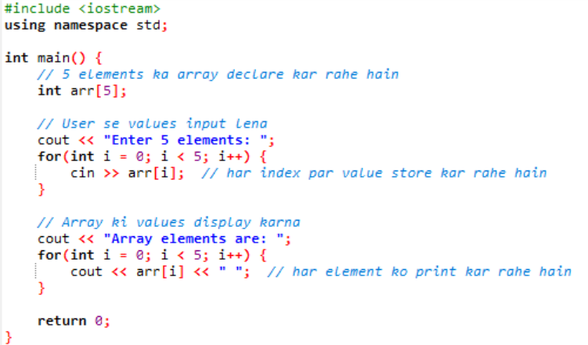

Output:
User enters values and program displays them.

Lab Tasks
Task 01:
Array Declaration and Initialization
• Declare an integer array called ”numbers” with a size
of 5.
• Initialize the array with values 10, 20, 30, 40, and 50.
• Display the values of the array elements using a loop.
Code
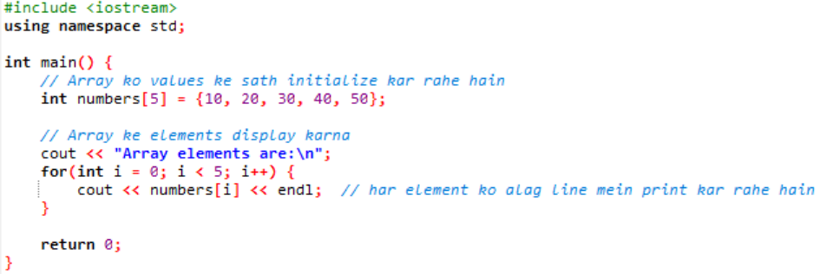
Task 02:
Accessing Array Elements
• Declare a character array called ”message” to store a word of your choice.
• Use a loop to access each character of the array and display it on a separate line.
Code
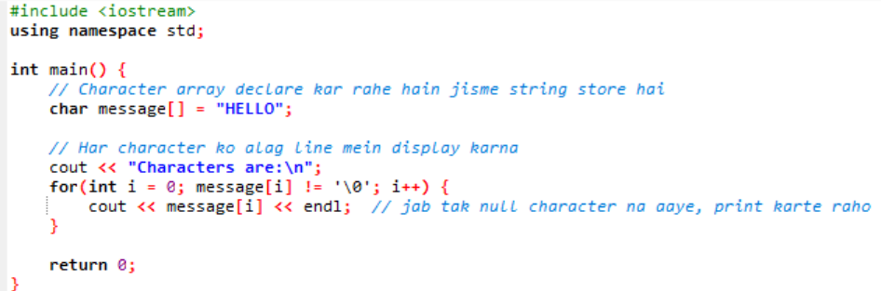
Task 3:
Copying Arrays:
- Declare two integer arrays: ”source” and ”destination”, each with a size of 5
- Initialize the ”source” array with some values.
- Use a loop to copy the elements of the ”source” array into the ”destination” arrayDisplay the values of both arrays to verify the copy operation.
Code
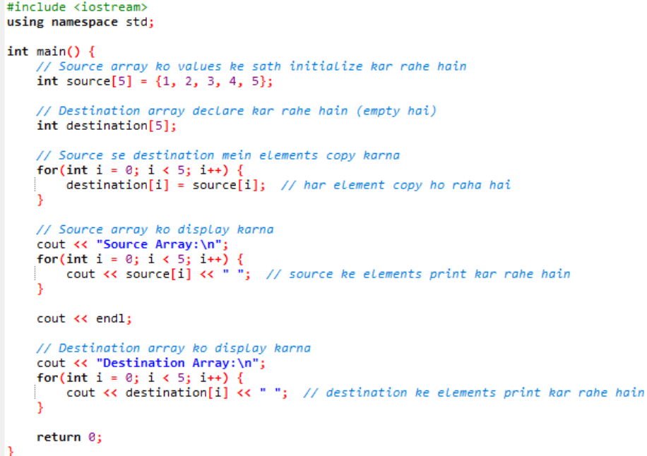
Task 4:
Array Sum:
• Write a C++ program that prompts the user to enter 5
numbers.
• Store the numbers in an integer array.
• Calculate the sum of all the numbers in the
array.
• Display the calculated sum.
Code:

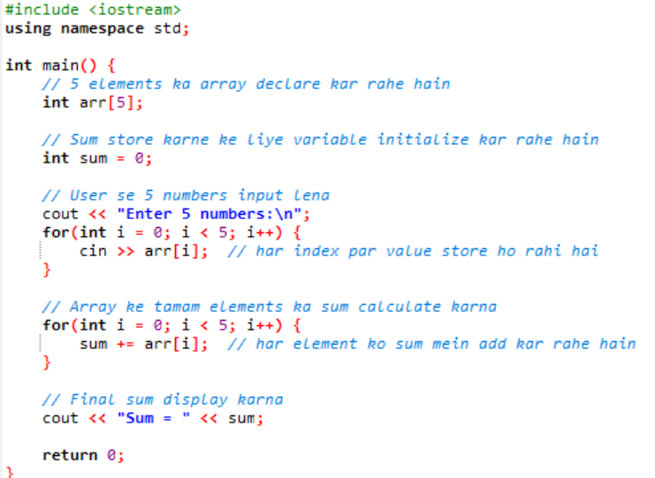

Conclusion:
This lab helped in understanding how arrays work in C++ and how to efficiently store and access multiple values using a single variable.

